Homeowner Insurance

User Manual

Important Point: *For Internet explorer users go to tools -> Compatibility View   
Settings, uncheck display intranet sites and use Microsoft compatibility list -> close*

The site is best viewed in 1366 x 768 screen resolution for IE

**Purpose of the document:**

*Intention of this document is to guide the user to effectively use the application.*

*The logical arrangement of the information and screen prints shall enable the user*

*To understand the sequence and navigation of the system.*

1. *Connecting to the application :*

*You must connect to the application using the following address:*

<http://ctsc00849530701:9000/HomeIns/>

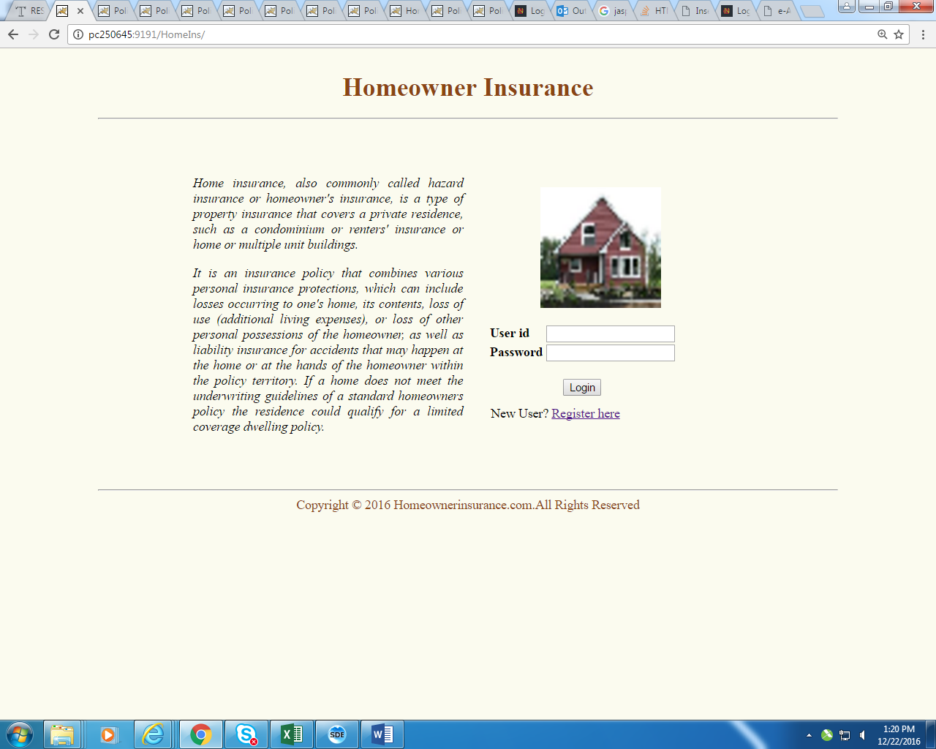

*Fig 1*

1. *Authentication :*

*User can login as* ***User*** *or* ***Admin*** *as per their authority. First we will go through User login*

*And check all the functionality of a user login. Refer screen print below for the User login.*



*Fig 2*

|  |  |
| --- | --- |
| **Field** | **Validation** |
| User Name | Cannot be Null |
| Length less than 20 characters |
| Only contain alphanumeric characters |
| Password | Cannot be Null |
| Length less than 20 characters |
| Only contain alphanumeric characters |

1. Normal User (**User Name:** USER , **Password:** USER)
2. Admin User (**User Name:** admin, **Password:** admin)

*New User Registration:*

*New user can be enrolled to the application by clicking* ***Register here*** *link (fig 2). User will*

*Be guided to fill registration form (fig 3).*

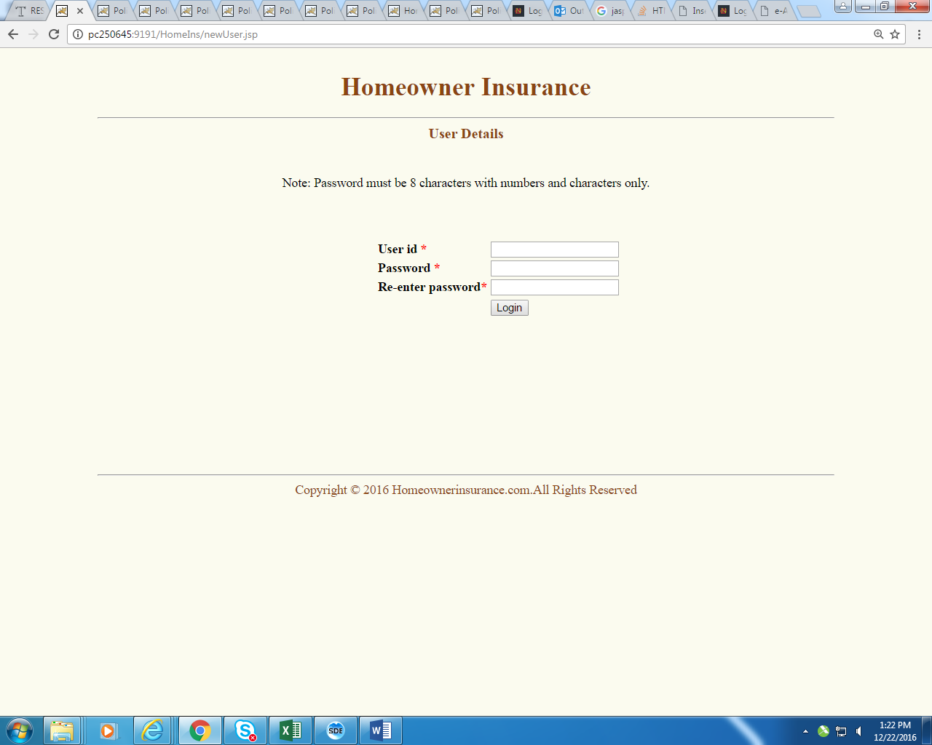 *Fig 3*

*User has to fill in all the mandatory field, not adhering to which lead to error message dialog*

*To pop up. User can cancel the pop up by clicking* ***ok*** *in the dialog box and fill in the required*

*Field. Refer fig 4 when user leaves User Id field blank, error dialog pops up.*

### Sample Data:

|  |  |  |
| --- | --- | --- |
| User Id | Password | Re-enter Password |
| Ctsuser100 | Pass1234 | Pass1234 |
| ctsuser007 | Pass1234 | Pass1234 |

|  |  |
| --- | --- |
| **Field** | **Validation** |
| User Name | Cannot be Null |
| Length less than 20 characters |
| Only contain alphanumeric characters |
| Password | Cannot be Null |
| Length less than 20 characters |
| Only contain alphanumeric characters |
| Re-enter Password | Cannot be Null |
| Length less than 20 characters |
| Only contain alphanumeric characters |
| Password & re-enter password must be same |

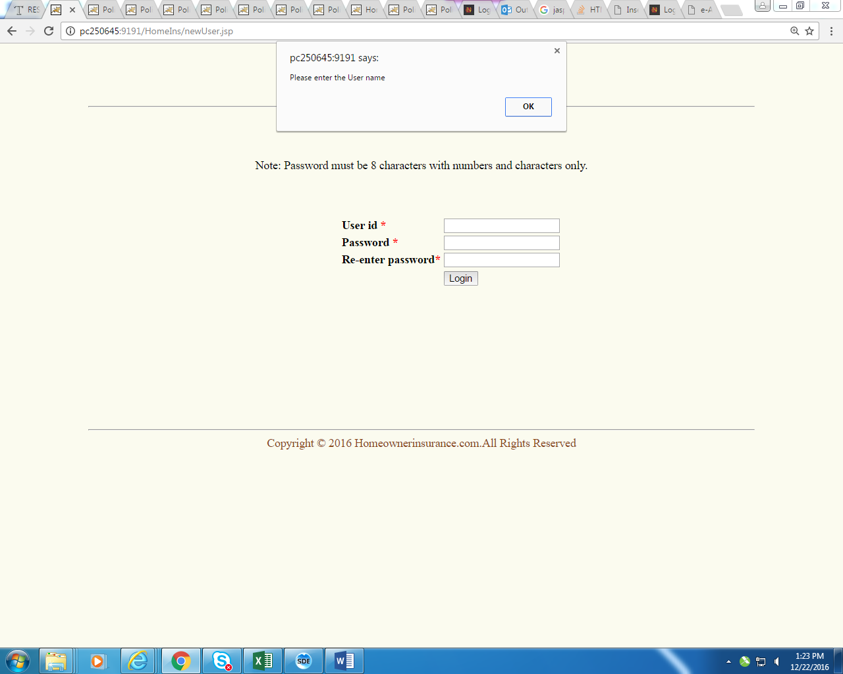

*Fig 4*

1. *Logging In as User :*

*User can login to the application using the same user id and password used for registering.*

*If user enters wrong credentials he will be prompted with error message as in fig 5.*

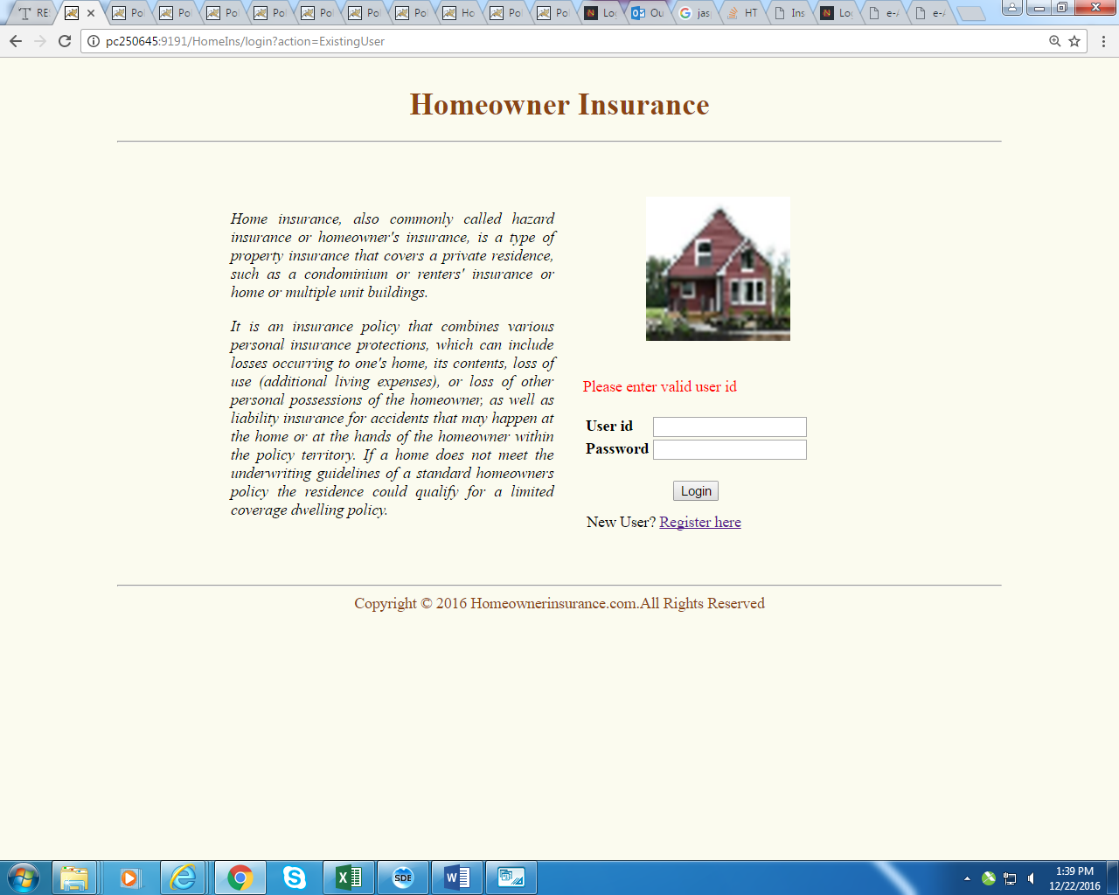

*Fig 5*

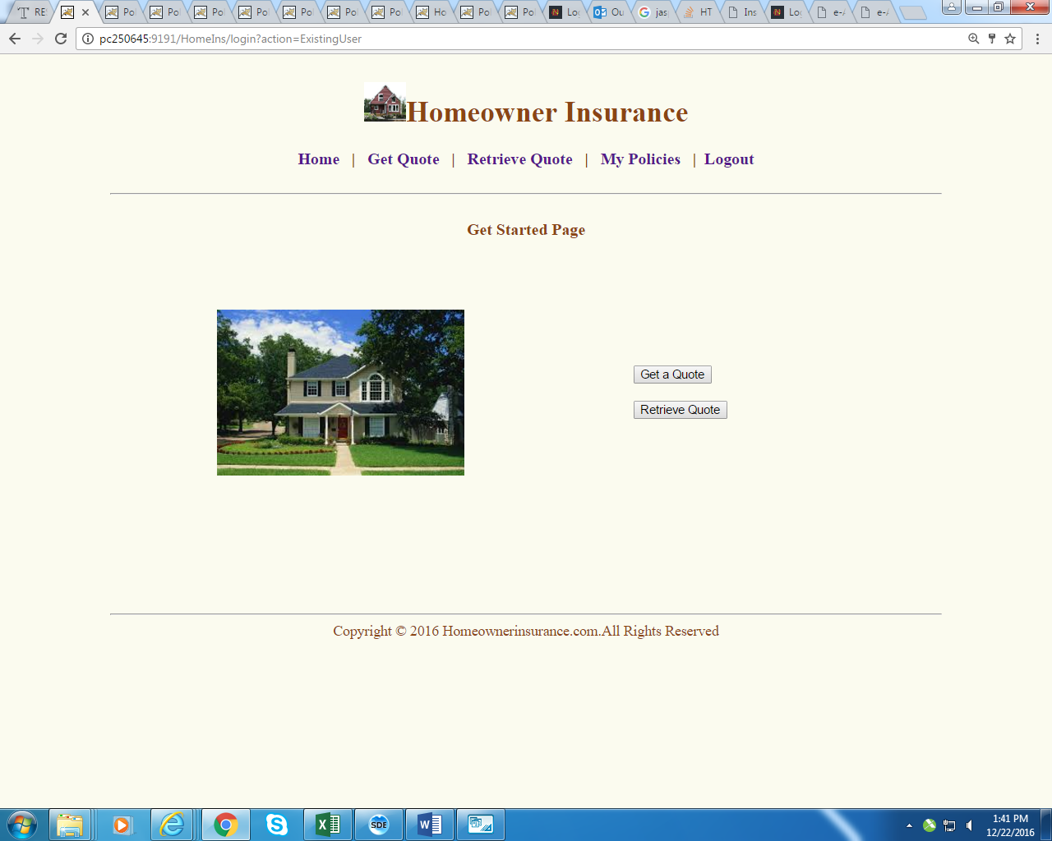

*Fig 6*

1. *Get a Quote:*

*Once user has successfully logged in, user can submit his quotation by clicking Get a Quote link in Get Started Page. Once user clicks get a Quote he will be redirected to Get Quote Page as shown in Fig 7*

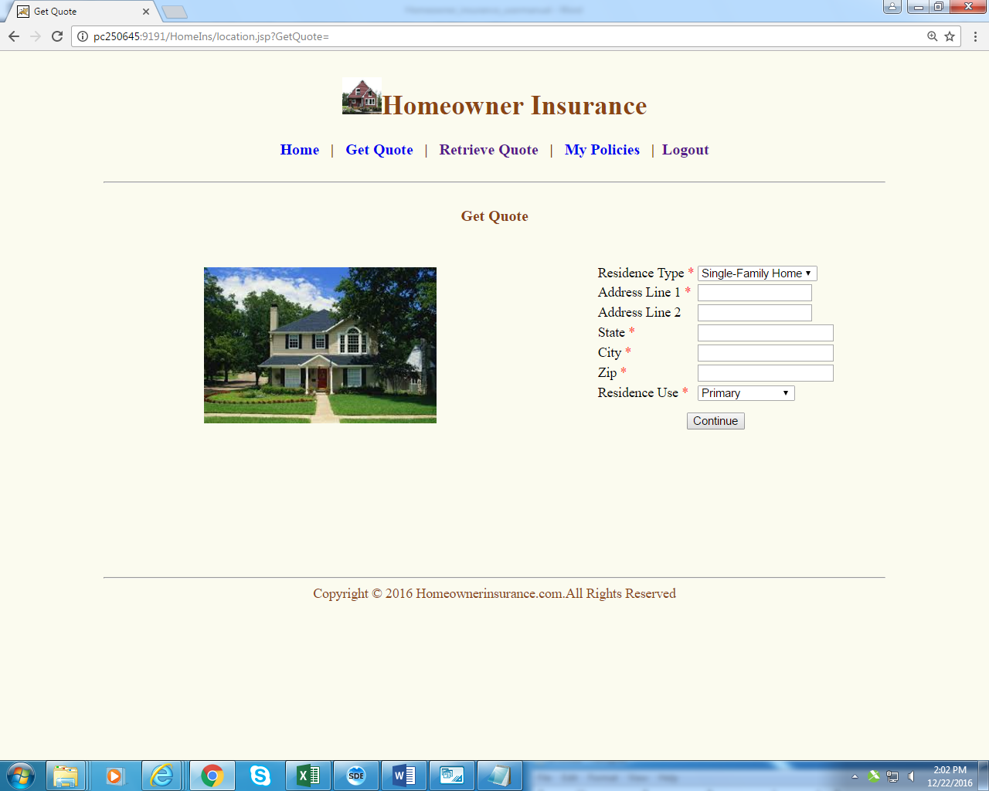

*Fig 7*

1. *Get Quote Page :*

*In Get Quote Page user has to enter all the mandatory field like Residence Type, Address*

*Line 1, State, City, Zip, Residency Use. If user enters any field blank or invalid he will be*

*Popped up with error message (fig 8).*

### Sample Data:

|  |  |  |  |  |  |  |
| --- | --- | --- | --- | --- | --- | --- |
| Residence Type | Address Line 1 | Address Line 2 | State | City | Zip | Residence Use |
| Single Family home | Main road 1 | Line 2 | Alaska | junta | 99801 | primary |
| Condo | Street 1 | Street 2 | Maharashtra | Mumbai | 456241 | Secondary |
| Townhouse | Lane 1 | Lane 2 | California | Albany | 12201 | primary |

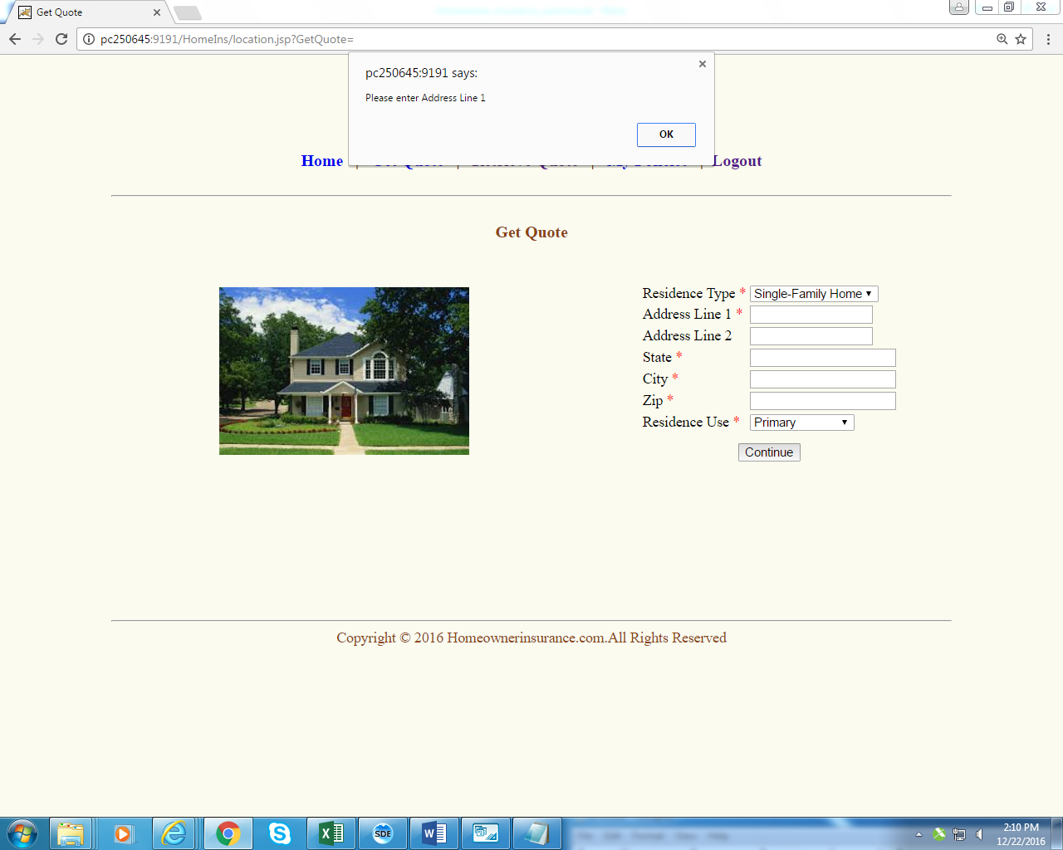 *. Fig 8*

|  |  |
| --- | --- |
| **Location Page** | |
| **Field** | **Validation** |
| Residence type | Must Be selected |
| Should be any one of the following values,   * Single-Family Home * Condo * Townhouse * Rowhouse * Duplex * Apartment |
| Address Line 1 | Cannot be Null |
| Length less than 50 characters |
| Only contain alphanumeric and ,-/. (space) characters |
| Address Line 2 | Cannot be Null |
| Length less than 100 characters |
| Only contain alphanumeric and ,-/. (space) characters |
| City | Cannot be Null |
| Length less than 15 characters |
| Only contain alphanumeric and space characters |
| State | Cannot be Null |
| Length less than 15 characters |
| Only contain alphanumeric and space characters |
| Zip | Cannot be Null |
| Length less than 10 characters |
| Only contain numeric values |
| Residence Use | Must be selected |
| Should be any one of the following values,   * Primary * Secondary * Rental Property |

1. *Homeowner Information :*

*Once user submits the quote he/she will redirected to Homeowner Information Page wherein*

*He must enter all the mandatory field like First name, Last name, Date of birth, Are you retired,*

*Social security number, Email address (fig 9)*

### Sample Data:

|  |  |  |  |  |  |
| --- | --- | --- | --- | --- | --- |
| First Name | Last Name | Date of Birth | Are you retired | Social Security Number | Email |
| Francis | Joshi | 04-05-1985 | No | 123654875 | joshi@gmail.com |
| Sunil | Kumar | 05-04-1991 | No | 879524632 | sunil@gmail.com |
| Radha | M | 04-05-1950 | Yes | 586742536 | radha@gmail.com |

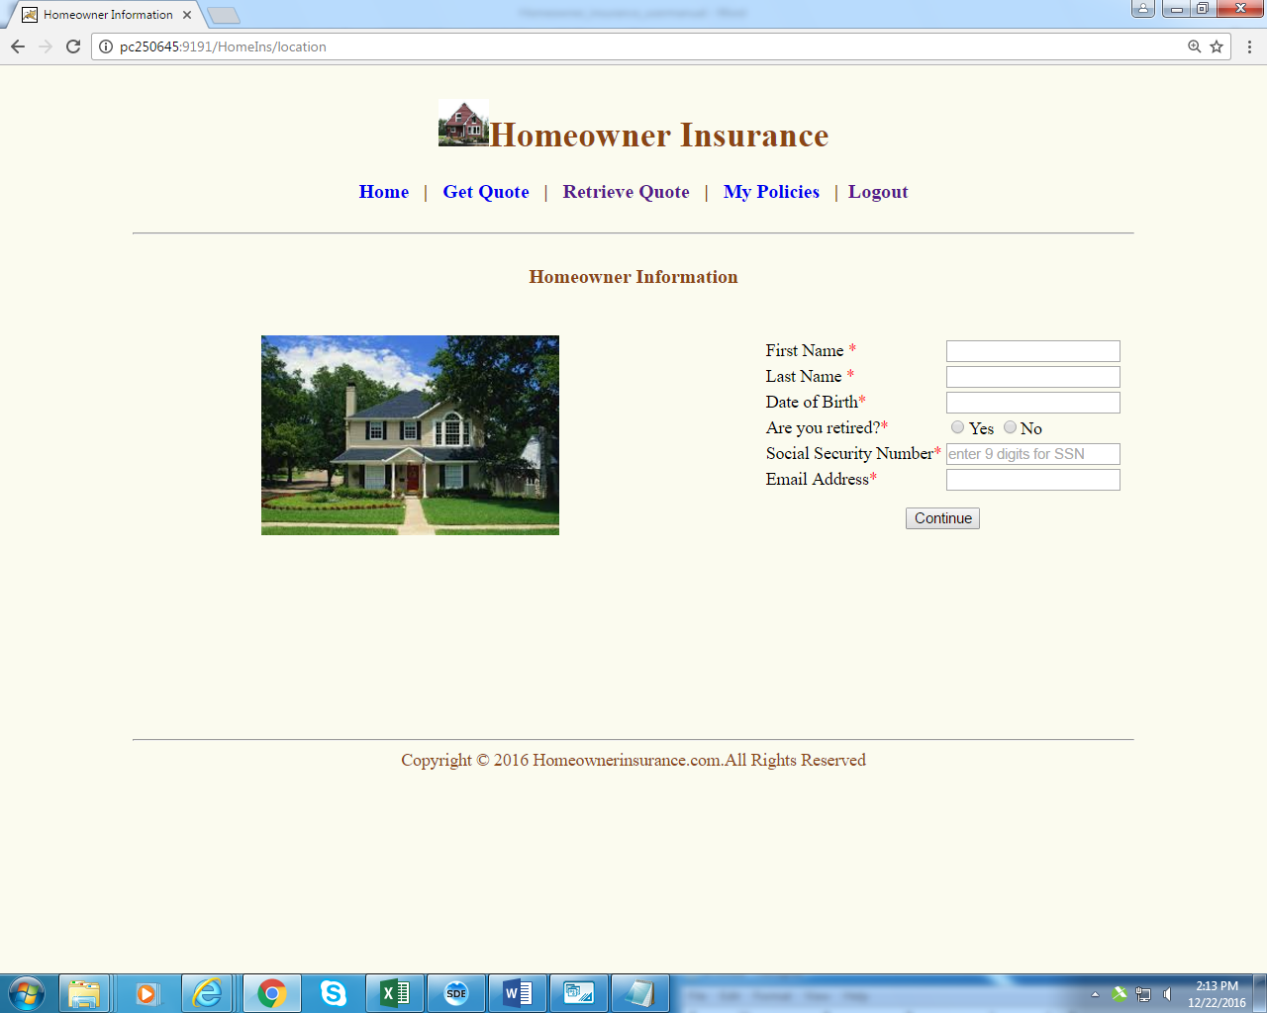

*Fig 9*

|  |  |
| --- | --- |
| **Home Owner Information Page** | |
| **Field** | **Validation** |
| First Name | Cannot be Null |
| Length less than or equal to 30 characters |
| Only contain alphanumeric and space characters |
| Last Name | Cannot be Null |
| Length less than or equal to 30 characters |
| Only contain alphanumeric and space characters |
| Date of Birth | Cannot be Null |
| Length less than or equal to 10 characters |
| Must follow the date format like (yyyy-MM-dd) |
| Are you retired | Must be selected |
| Social security number | Cannot be Null |
| Length less than or equal to 9 characters |
| Only contain numeric values |
| Email Address | Cannot be Null |
| Length less than or equal to 50 characters |
| Must be in valid email format |

1. *Property Details : By clicking continue button from homeowner information user will be redirected to Property Details page* wherein user will be submitting the form with all the mandatory fields of his residence like Market value of house , built year of house , square footage, Dwelling style, Roof material ,Type of garage, Number of full baths ,number of half baths, swimming pool (fig 10)

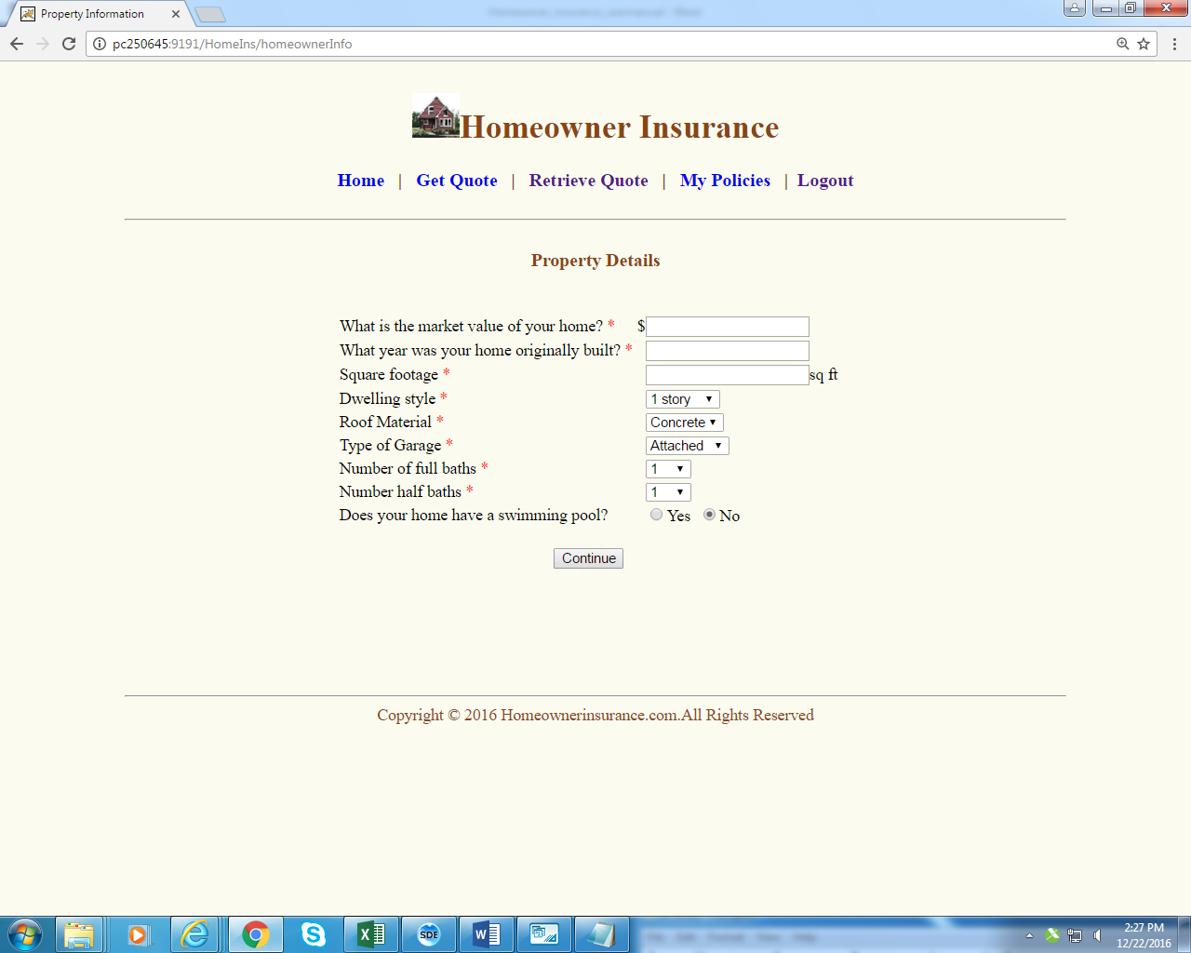 *Fig 10*

|  |  |  |  |  |  |  |  |  |
| --- | --- | --- | --- | --- | --- | --- | --- | --- |
| What is the market value of your home | What year was your house originally built | Square footage | Dwelling style | Roof Material | Type of Garage | Number of Full Baths | Number of Half Baths | Does your home have swimming pool |
| 25000 | 2010 | 1500 | 1 story | Concrete | Attached | 2 | 1 | No |
| 15000 | 2010 | 2000 | 1.5 story | Clay | Detached | 2 | 1 | No |

1. *Coverage Details : User can check the coverage details like Quote id, Monthly premium ,Dwelling coverage, Detached Structure ,Personal property ,Additional living expense ,Medical expense , Deductible(fig 11) . User can get additional information on all the calculations by clicking Additional info link (fig 12). If user is interested to buy the quote he can click proceed to buy. User will be redirected Quote Details (fig 13) from where he can click rest of information to buy the quote.*

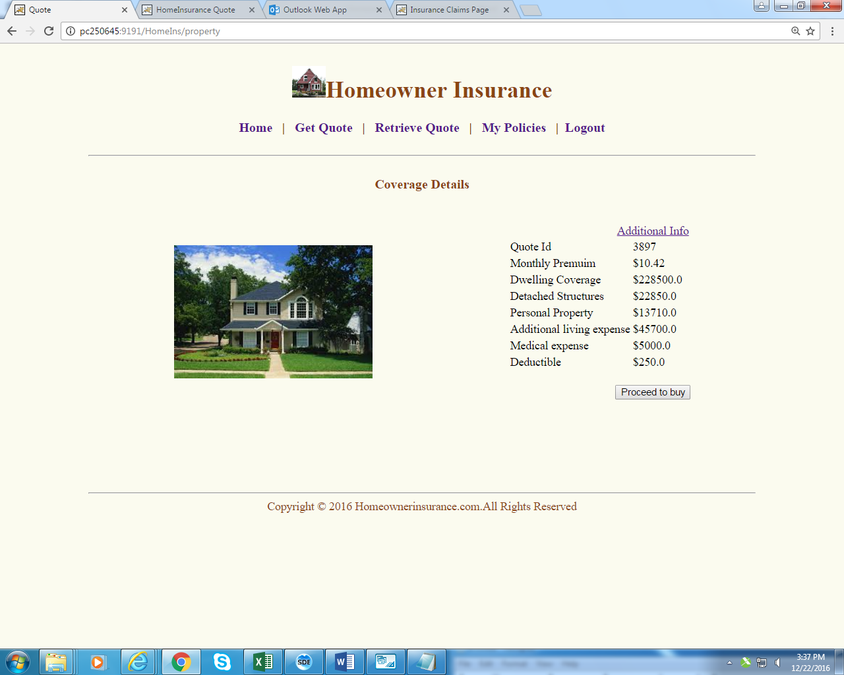

*Fig 11*

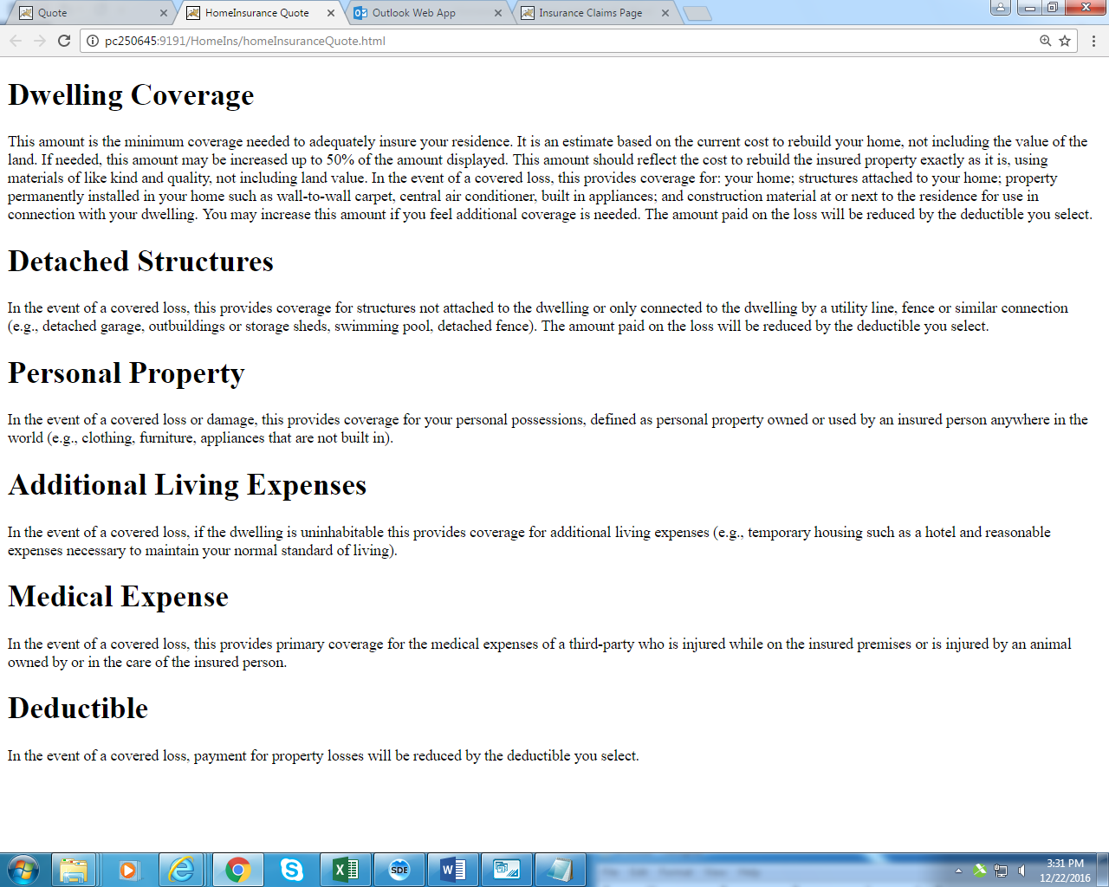

*Fig 12*

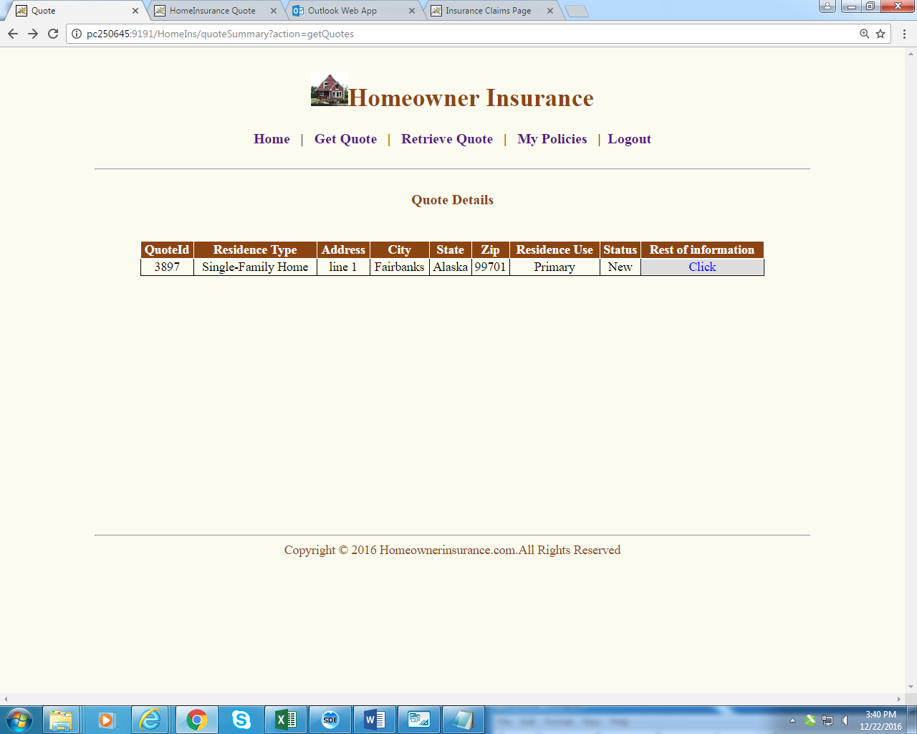

*Fig 13*

1. *Quote Summary :*

*In Quote summary page he can check his monthly premium, Location details, Homeowner details, Property details, Coverage details (fig 14).*

*If the user wants to buy the policy he can click Buy Quote which will redirect him to Buy policy page (fig 15) wherein he can enter the date from which he has to start the policy (less than 60 days), after clicking the hyper link to Please click and read terms and conditions before buying policy, read the terms and conditions (fig 16) user can click the check box and click submit button*

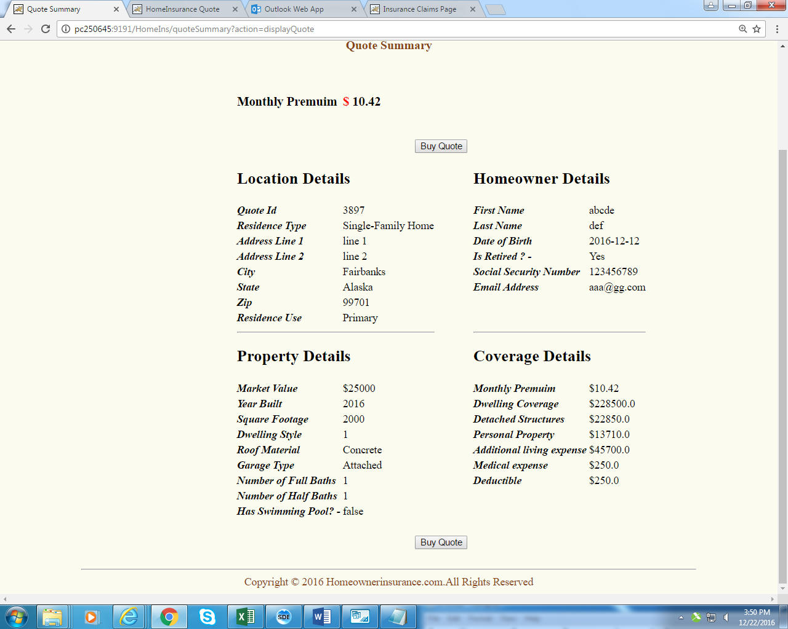

*Fig 14*

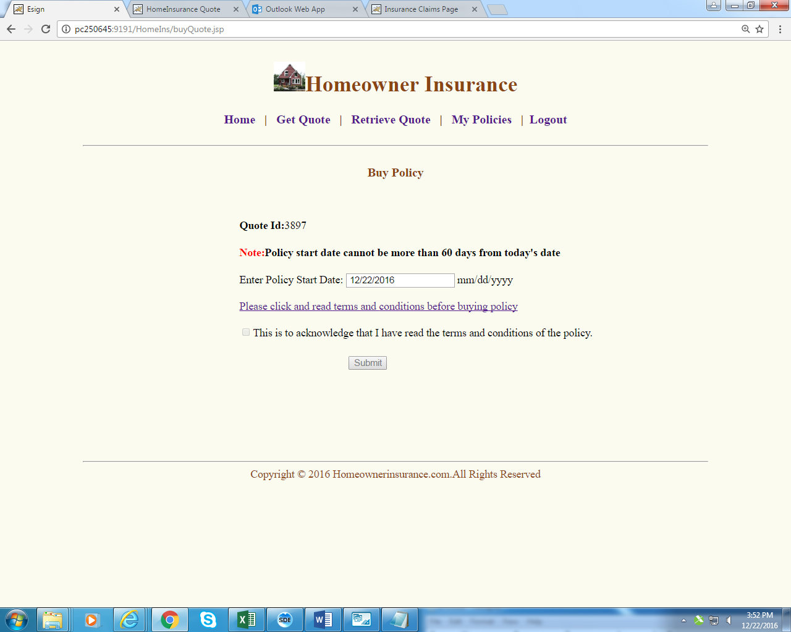

*Fig 15*

|  |  |
| --- | --- |
| **Buy Policy Page** | |
| **Field** | **Validation** |
| Policy Start Date | Cannot be Null |
| Length less than or equal to 10 characters |
| Must follow the date format like (yyyy-MM-dd) |
| Date can be with in next 60 days from current date. |

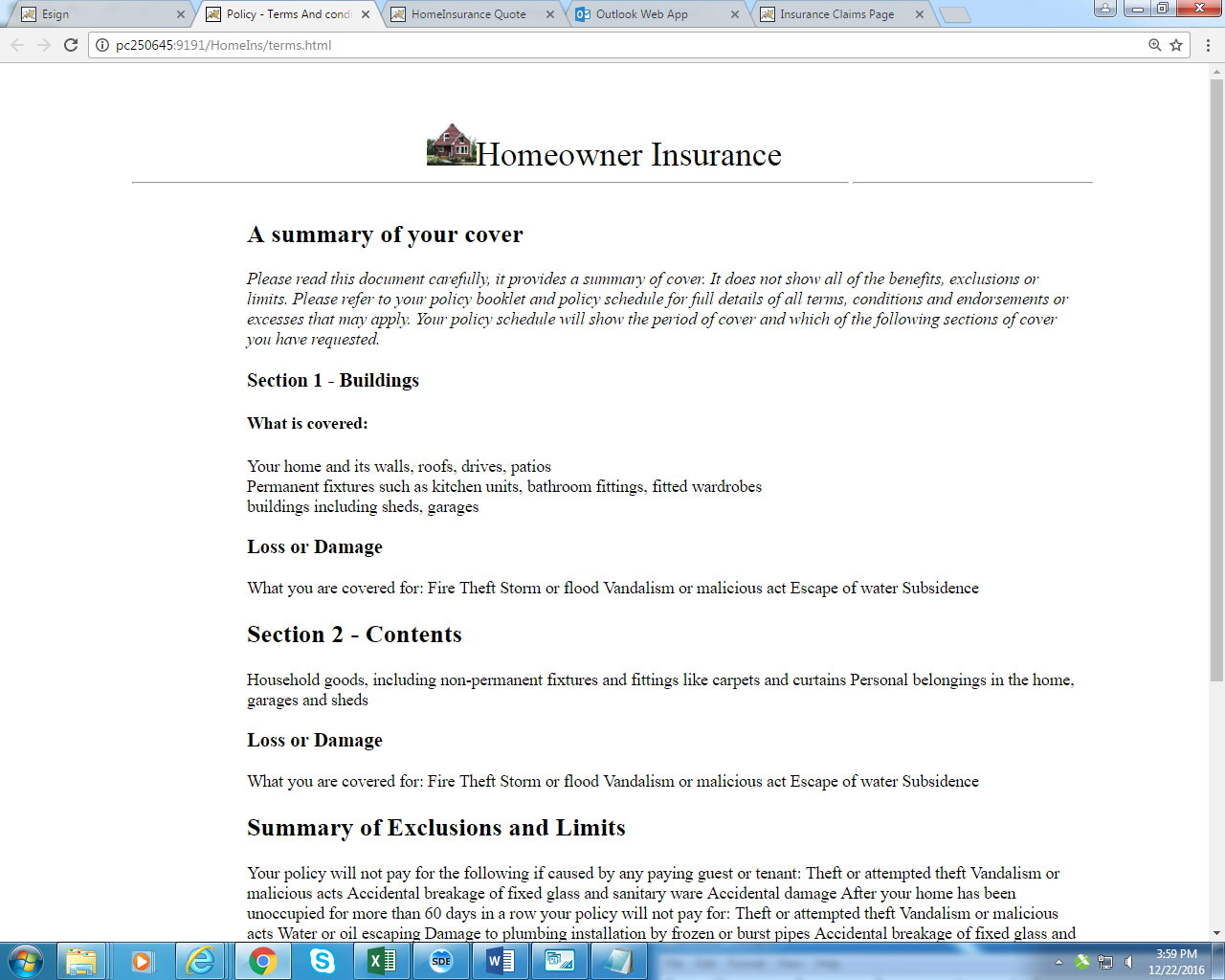

***Fig 16***

*12. Policy Confirmation:*

*In policy confirmation page user can check his Quote Id, Policy key,*

*Policy effective date, policy end date, policy term, policy status*

*(Fig 17)*

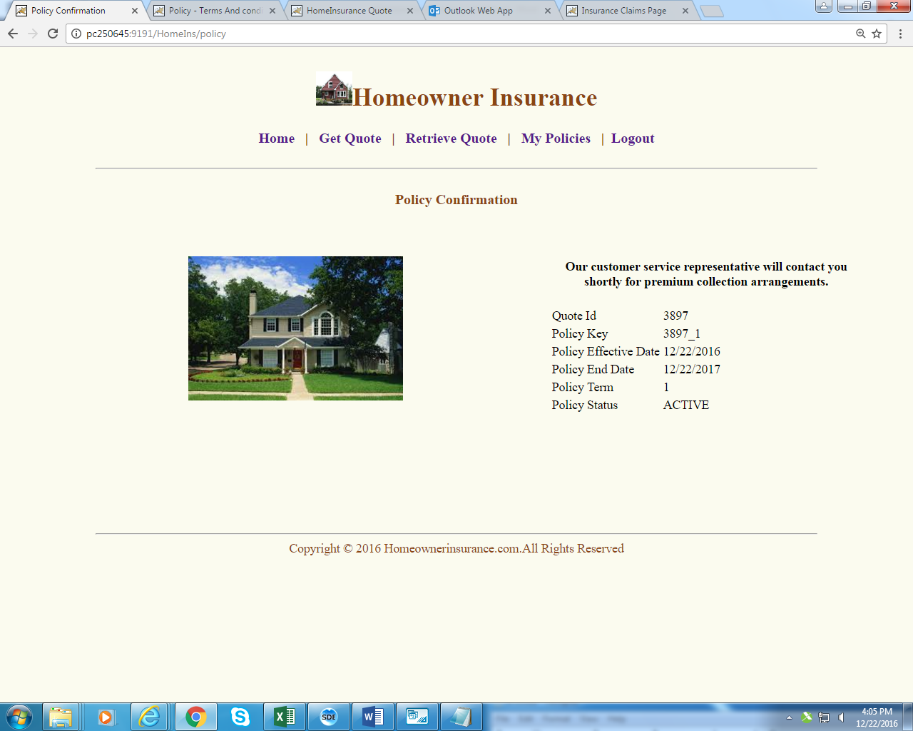

***Fig 17***

1. *Admin Login :*

*Admin can log in to the system by entering admin as user id and password, he will be redirected to Admin screen page (fig 18) wherein he can search a particular user by entering user id*

|  |  |
| --- | --- |
| **Buy Policy Page** | |
| **Field** | **Validation** |
| User Name | Cannot be Null |
| Length less than or equal to 20 characters |

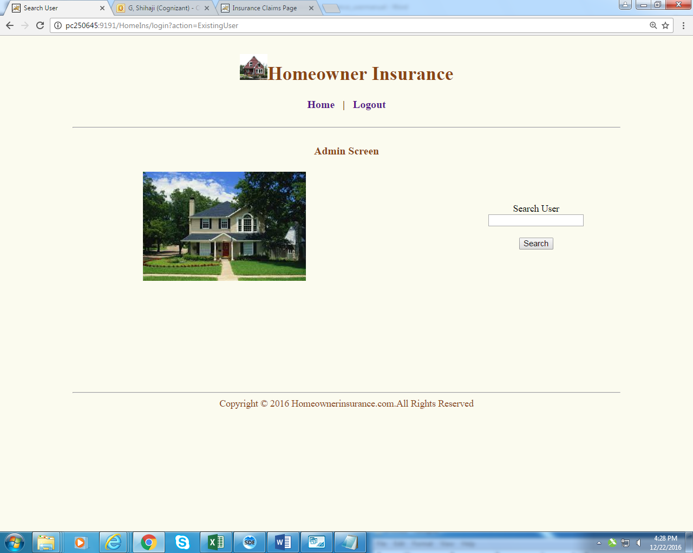

***Fig 18***

*13. User Policies*

*In user policies page admin can either renew a policy or cancel a policy by clicking the respective links (fig 19). Policies can be renewed only 1 month before the policy end date, but admin can renew cancelled policy. If admin cancels a policy he will be getting a confirmatory message and a new page with cancelled policy details (fig 20). If the admin renew a policy he will be redirected to new page with renewed policy details (fig 21)*

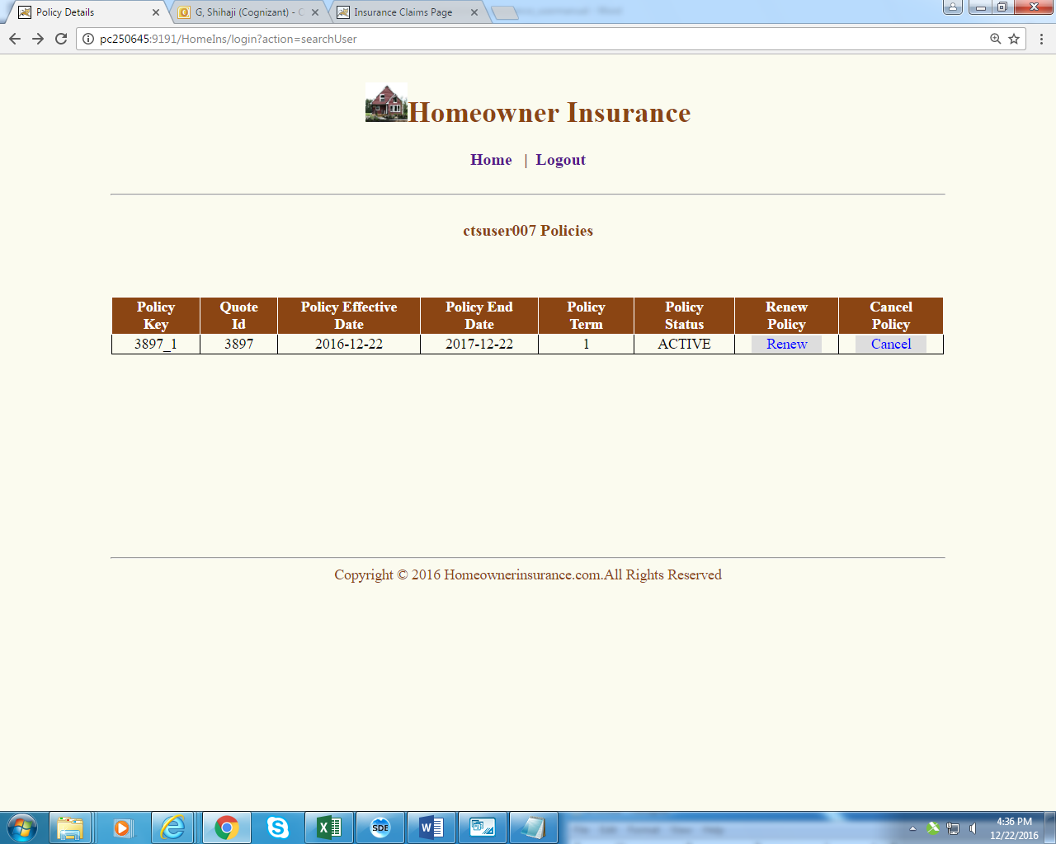

***Fig 19***

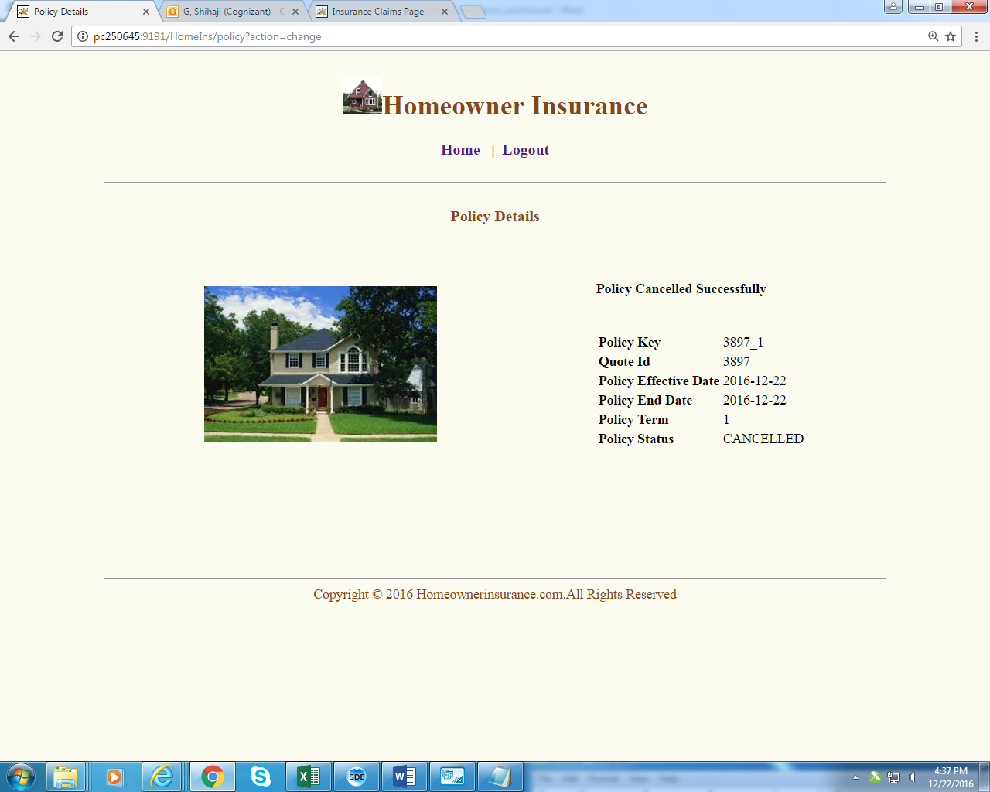

***Fig 20***

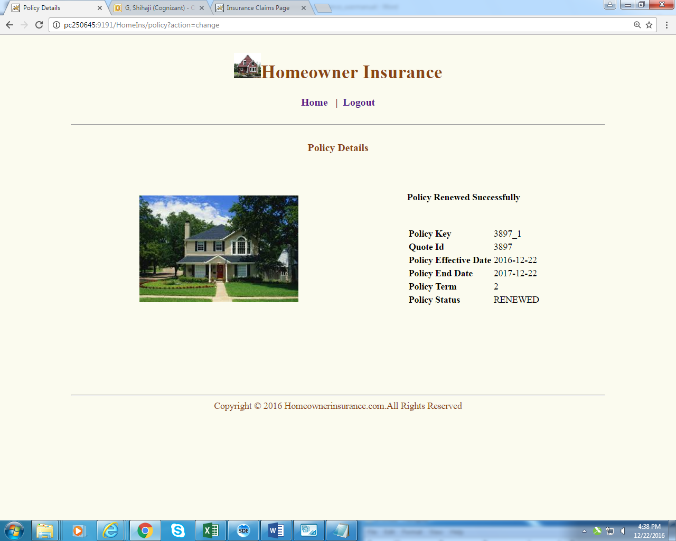

***Fig 21***